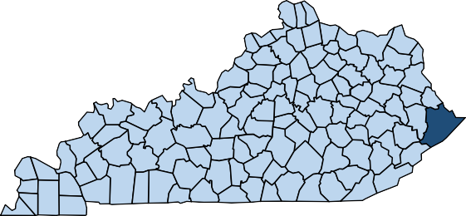
REPORT TO THE PEOPLE
Pike County 2023
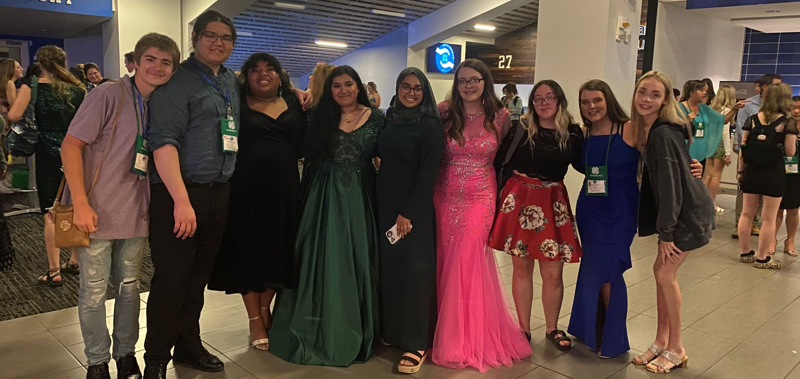
DID YOU KNOW...Seven Pike County teens participated in 4-H Teen Conference, where they resided in University of Kentucky dorms and developed life, communication, and social skills through attending workshops and activities?

JUST A FEW OF OUR PROGRAMS

4-H Programs
EFNEP Successes
Community Arts
Programs
Pike County
Master Gardeners

Website: pike.ca.uky.edu
Facebook: @UKExtensionPikeCounty
YouTube: @Pike County KY Cooperative Service

For More Information, Please Contact us at:
Pike County Extension Office • (606) 432-2534 • pike.ext@uky.edu • 148 Trivette Drive, Pikeville, KY 41501

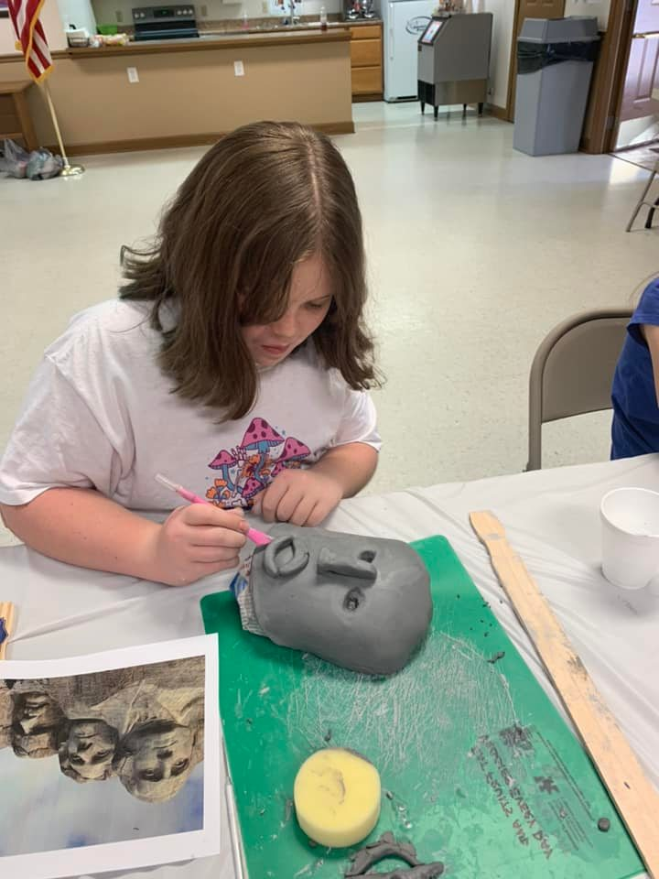
Pike County 4-H presented programs to 3,099 youth through clubs where they learned about leadership, civic engagement, and health. Those youth presented 2,840 at the 4-H fairs held at each high school, with 46 of those exhibits advancing on to the Kentucky State Fair.
4-H YOUTH DEVELOPMENT
One of the biggest activities of the year is the 4-H camp and Pike County had 180 youth at the J.M. Feltner 4-H camp. Over five days they threw themselves into activities where they developed social skills and decision-making skills and experienced the great outdoors by hiking, canoeing, zip lining, and swimming.
The 4-H Teen Council consisted of 12 middle and high school students that honed their leadership and volunteer skills through various meetings and community activities. Two council members served on the KY State Teen Council and one of our previous year’s members went on to serve as Kentucky 4-H Treasurer. A diverse group of seven teens participated in the 4-H Teen Conference, where they resided in the University of Kentucky dorms and developed life, communication, and social skills through attending workshops and activities.
During the Reality Store program, 98 youths got a chance to explore career opportunities and make financial and lifestyle choices. Here they learned about budgeting, goal setting, and the correlation between grades and future career opportunities.
Forty-eight high school juniors and sophomores participated in the American Private Enterprise program where they had the opportunity to meet local professional leaders, learn how our economy works, and used their problem solving skills to assist corporations or cooperative boards.
During several weekends and summer months, Pike County 4-H held day camps in which we partnered with Family Resource and Youth Services Centers and AppHarvest to educate 40 youth about art, woodworking, nutrition, and agriculture technology.

AGRICULTURE AND NATURAL RESOURCES

The Pike County Master Gardeners are very active in educating the public, in doing tours, and trainings in other areas of the state. Recently, they did a tour of the Lexington and Louisville areas. In Lexington, they visited the Henry Clay Home, the Landscape Garden Center/ Arboretum, Stream Restoration on UK’s campus, and the UK South Farm to see and learn about plants and see garden research being conducted. In Louisville, they visited Waterfront Botanical Gardens, White Hall, Yew Dell Gardens, Crestwood, Louisville Champions and Parkway Gardens. Each year they conduct a “plant swap,” a “Garden Tour,” and maintain the Extension Office Demo Garden. Assist with the Appalachian Heritage Seed Swap and the Pikeville Farmers Market. They regularly assist with various workshops and trainings.
The Demo garden shows how to raise flowers,

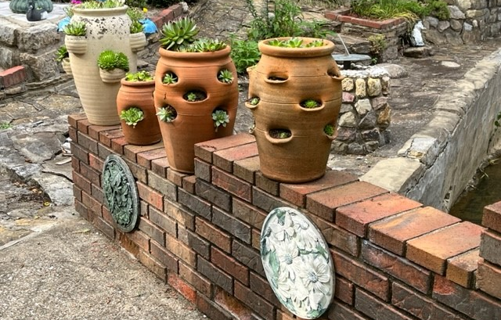
fruits, and vegetables in raised beds and a small footprint garden. Master Gardeners work diligently in the Demo Garden to show that it doesn’t take acres of land to produce both food and flowers. They also maintain a small garden plot to demonstrate vegetable growth for the average homeowner.

FAMILY AND CONSUMER SCIENCES

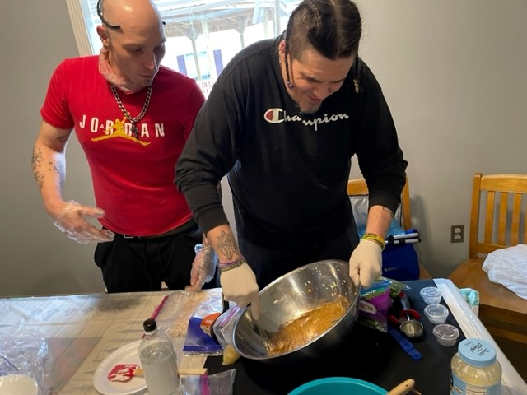
For the tenth year, the Pike County Cooperative Extension Service Expanded Food and Nutrition Education Program partnered with West Care Rehabilitation to provide nutritional classes to their clients.
The Healthy Choices For Everybody curriculum was taught as residents learned how to prepare fresh healthy foods by using the five food groups. This is a hands-on class where participants take turns in helping to preparation of the food demonstration. They also gained skills in reading recipes, how to properly measure dry and liquid, reading labels, meal planning, budgeting for food spending, food safety, and proper exercise. Family health was emphasized as they learned how to provide healthy food and snacks for children, and how exercise will improve the physical and emotional health of the entire family.
Twelve clients entered the program with a 100% graduation rate. Eighty-seven percent of

COMMUNITY ARTS
Pike County Extension Community Arts received a $5,000 KY Arts Council Creative Aging and Lifelong Learning Grant. Participants took part in 24 arts activities over five months. Activities included therapeutic art sessions, yoga classes, dulcimer playing and building workshops, jewelry making, ink art, pottery, flowerpot planning and decorating, and opportunities to see theatre productions and attend a festival, all completely free. To date, we’ve had 64 participants.
Appalachian Symphony offers free lessons every Saturday in stringed instruments to anyone who shows up. Appalachian Symphony and our dulcimer group traveled to Berea, Whitesburg, and Hindman this year to network and perform with other groups. The group was given an award from East Kentucky Indian Culture Association for their participation in the Pike County Diwali celebration.
Artists Collaborative Theatre performed its first full season since the COVID-19 pandemic. Their season consisted of six shows with eight to twelve performances each. This included two

graduates show a positive change in the five food groups, 93% on improvement in diet quality, 72% showing a change in Food Resource Management, and 89% improvement in food safety.

kids’ shows: Disney’s The Aristocats KIDS and The Best Christmas Pageant Ever, each with 20+ students participating.
We regularly offered community crafts, such as flowerpot decorating, painting, card making, etc. at the Extension office as well as the Pike County Farmers Market. At our most recent pumpkin painting event, 60 people attended.
Working with the UK College of Fine Arts, artist Rae Goodwin came to Pike Central High School to host an interactive art project – Grandparents as Superheroes, with 92 students participating.

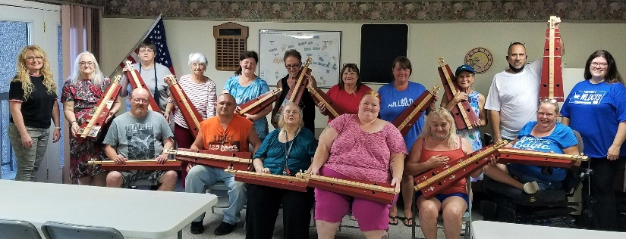

NOTHING IS OUT OF REACH.
Healthy Families. Healthy Homes. Healthy Communities.

Website: extension.ca.uky.edu

Twitter: @UKExtension
Facebook: @UKCooperativeExtension
YouTube: @UKAgriculture
- 37,770 Kentucky youth applied the skills they learned in 4-H to home, school, or community.
- 5,510 Kentucky producers implemented sustainable practices they learned through Extension programs.
- 6,121 Kentucky families grew a garden using Extension resources.
- 2,544 Kentucky beekeepers incorporated best practices recommended by Extension.
- 17,504 Kentuckians reported improved lifestyles through a focus on proper nutrition, disease and injury reduction and comprehensive health maintenance.
... just a few ways Extension supports Kentucky

University of Kentucky Cooperative Extension
S-107 Ag Science Center North Lexington, Kentucky 40546-0091
(859) 257-4302

Educational programs of Kentucky Cooperative Extension serve all people regardless of economic or social status and will not discriminate on the basis of race, color, ethnic origin, national origin, creed, religion, political belief, sex, sexual orientation, gender identity, gender expression, pregnancy, marital status, genetic information, age, veteran status, or physical or mental disability.

